This was my first engineering project in the Spring of my Freshman year. The purpose of this project was to build a circuit that takes the output of a sensor that measures the distance raised from the starting point. This project was to create a way for a disabled person who only has legs to turn on a fan by lifting their leg. A diagram of a circuit
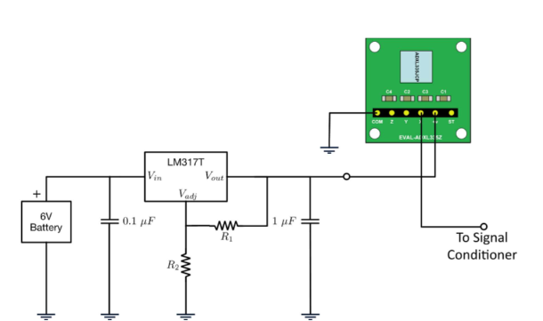

The first figure shows the signal conditioning circuit to the fan. The second figure shows the voltage regulator to accelerometer connections.